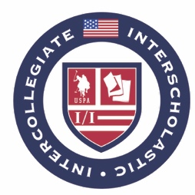
2021-2022 I/I Season Tournament Conditions Addendum

SUMMARY

- The 2020-2021 school year will not count towards any intercollegiate player’s years of eligibility.
- For the 2021-2022 I/I Season, second year grad students are eligible to compete, provided they meet all other I/I eligibility requirements.

